Description of Testing

This experiment can be broken into four sections, each containing seven runs. In each section we ran either GPOPS Planner or Backman Planner with either reverse motion allowed or forward motion only. The starting pose was initialized to [0.0 ,0.0, pi/2] while the goal pose was iterated through the following list. The constraints on all parameters (curvature and its derivatives and speed and its derivatives) were the same across all runs. The MPC cost function was also held the same across all runs.

Experiment was performed at Robert Mondavi Institute on empty vineyard rows.

Goal States:

1. [1.0, 0.0, -pi/2]
2. [1.5, 0.0, -pi/2]
3. [2.0, 0.0, -pi/2]
4. [2.5, 0.0, -pi/2]
5. [3.0, 0.0, -pi/2]
6. [3.5, 0.0, -pi/2]
7. [4.0, 0.0, -pi/2]

# Experiments

## Section 1: GPOPS Planner, Forward motion only

### Planned Paths

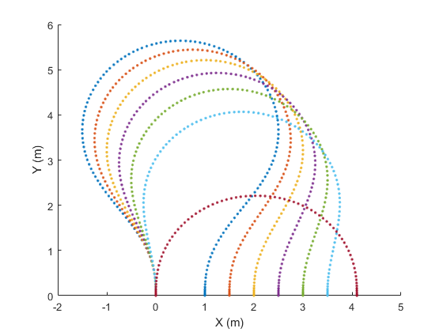

### Tracked Paths

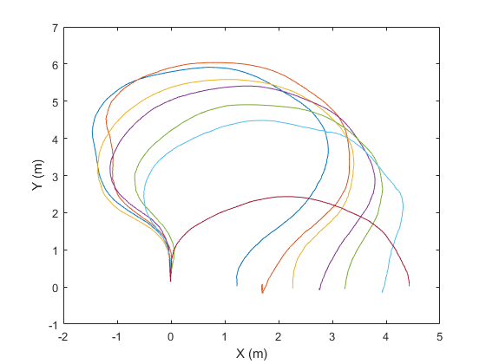

## Section 2: GPOPS Planner, Reverse Motion Allowed

### Planned Paths

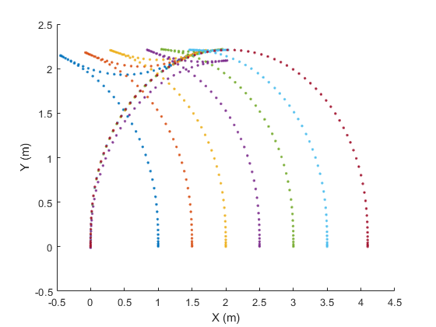

### Tracked Paths

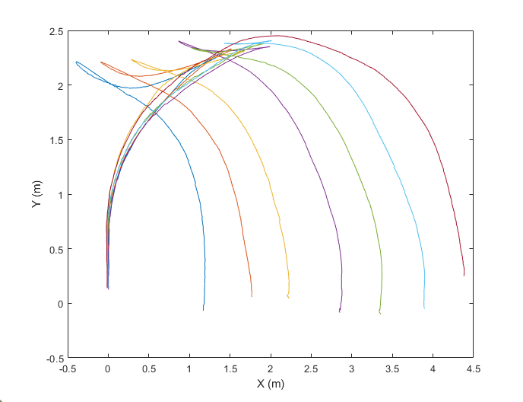

## Section 3: Backman Planner, Forward Motion Only

### Planned Paths

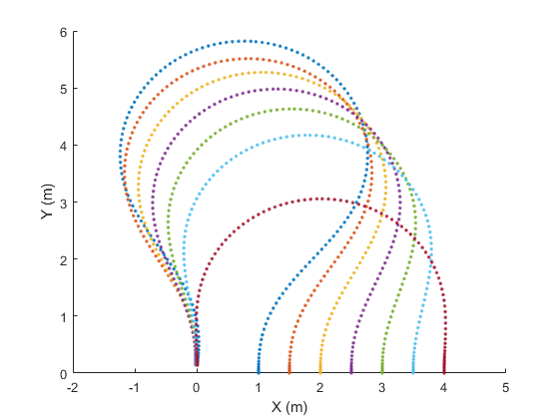

### Tracked Paths

## Section 4: Backman Planner, Reverse Motion Allowed

### Planned Paths

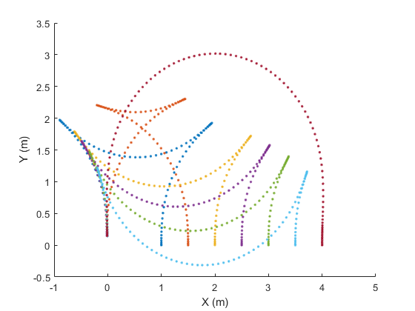

### Tracked Paths

# Analysis

# Metrics Averaged over Each Set of Runs

|  |  |  |  |  |
| --- | --- | --- | --- | --- |
|  | Mean Lateral Error (m) | Max Lateral Error (m) | Mean Heading Error (rad) | Max Heading Error (rad) |
| GPOPS -  Forward Motion Only | 0.2984 | 0.4840 | 0.0996 | 0.4021 |
| GPOPS -  Reverse Motion Allowed | 0.1732 | 0.3220 | 0.1279 | 0.9329 |
| Backman -  Forward Motion Only | 0.3045 | 0.5172 | 0.0937 | 0.3657 |
| Backman -  Reverse Motion Allowed | 0.1225 | 0.2860 | 0.1254 | 0.8442 |

# Planning Computation Times

On Dell Latitude E6520

|  |  |
| --- | --- |
|  | Average Time to Plan |
| GPOPS | 11.1s |
| Backman | 0.67s |

# Final Time of Paths

Note that planning times go down because it is faster to make maneuvers with larger turns.

## Final Time in planning

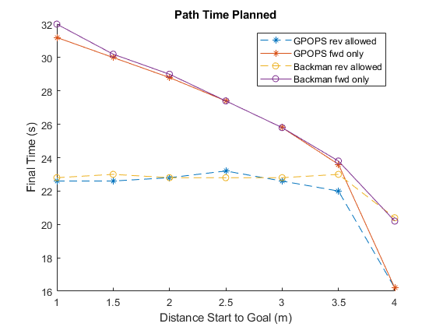

## Final Time for Actual (Tracked) Paths

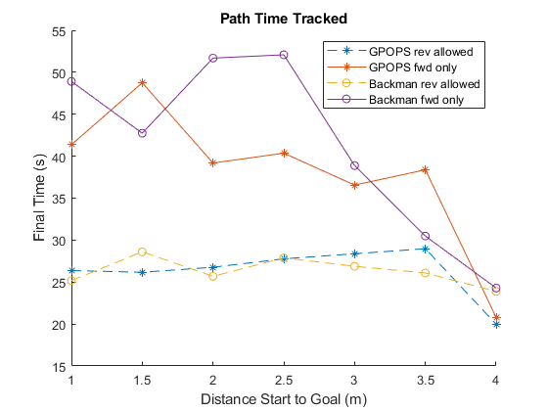

## Analysis of two single runs

### Backman, Reverse motion allowed from [0, 0, pi/2] -> [0, 2, -pi/2]

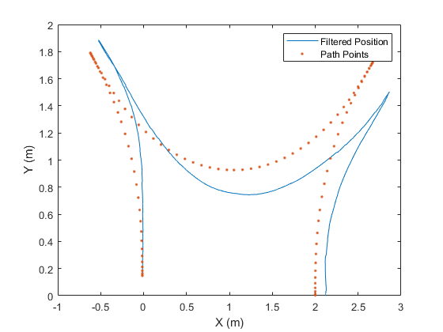

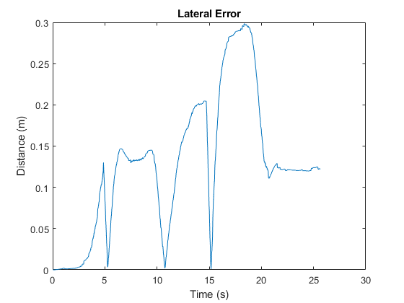

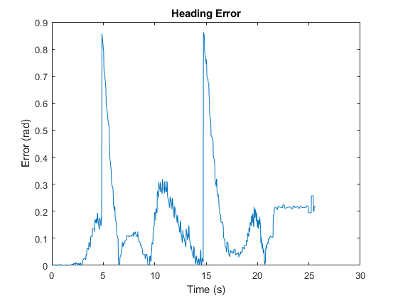

### GPOPS, Reverse motion allowed from [0, 0, pi/2] -> [0, 2, -pi/2]

